Name: …………..……….......……

|  |  |  |
| --- | --- | --- |
| **Calculator Free** | **/23** | **%** |
| **Calculator Allowed** | **/35** | **%** |
| **Total** | **/58** | **%** |

Mathematics Methods, Year 12, 2018

Test 5 – CRVs and the Normal Distribution (& logs)

25 minutes working time.

Calculator Free Section (no notes, no calculators)

SCSA Formula sheet allowed

**Question 1 [8 marks: 2, 3, 3 ]**

1. Use the rules of logarithms to solve for $x in$
$$\log_{2}10+\log_{2}x=2$$

2. Solve for $x in$

$\log_{x}4- \log_{x}3= -2$

1. Use common logarithms to solve for $t.$

$$\frac{2^{2t+1}}{2^{1-t}}=5$$

**Question 2 [9 marks: 2, 2, 2, 3]**

Lee never arrives at school before 8.00 am and never arrives after 9.00 am. The probability distribution function for her time, *t*, of arrival at school is given below, with constant *b* and *t* being measured as minutes after 8.00am.

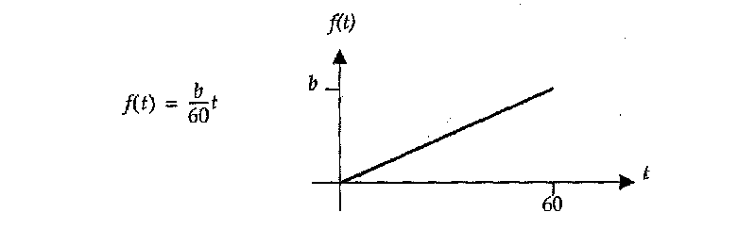

(a) Show that the value of *b* is $\frac{1}{30}$

(b) Calculate the probability that Lee arrives at school

(i) before 8.30 am,

(ii) after 8.40 am.

(c) The expected value of *X, E(X)* is 40 and the variance of *X*, $Var\left(X\right)$, is 200.

(i) Determine $E\left(2X+1\right)$.

(ii) Determine $Var\left(2X+1\right)$.

**Question 3 [6 marks: 1, 2, 1, 1, 1]**

This graph is of a uniform random variable, *x*.

(a) Determine the value of k.



(b) Complete the rule:

f(x) =

(c) Calculate *P*(3 ≤ *X* ≤ 6)

(d) Calculate *P*(*X* < 5 | *X* > 3)

(e) Calculate ***m*** if *P*(*X* > ***m*** | *X* > 5) = 0.25

Name: …………..……….......……

Mathematics Methods, Year 12, 2018

|  |  |  |
| --- | --- | --- |
| **Total** | **/35** | **%** |

Test 5 – CRVs and the Normal Distribution (& logs)

35 minutes working time.

Calculator Assumed Section (notes allowed)

SCSA Formula sheet and calculators allowed

**Question 4 [8 marks: 2, 2, 2, 2]**

*X* is a continuous random variable with probability density function given by:

$$f\left(x\right)=\frac{x}{50} 0≤x≤10$$

(a) Show that $f\left(x\right)$ is a probability density function.

(b) Find:

(i) $P\left(1≤X≤5\right)$

(ii) $P\left(X≤5\right)$

(iii) $P\left(X≥1 | X≤5\right)$

**Question 5 [8 marks: 1, 2, 2, 3]**

Rebecca sells potatoes at her organic fruit and vegetable shop that have weights normally distributed with a mean of 230 grams and a standard deviation of 5 grams

(a) Determine the probability that one of Rebecca’s potatoes selected at random, will weigh between 223 grams and 235 grams.

(b) Five percent of Rebecca’s potatoes weigh less than *w* grams. Determine *w* to the nearest gram.

(c) A customer buys 12 potatoes.

1. Determine the probability that all twelve potatoes weigh between 223 grams 235 grams
2. If the customer is selecting the 12 potatoes one at a time, determine the probability that it takes the selection of eight potatoes before six potatoes weighing between 223 grams and 235 grams have been selected.

**Question 6 [7 marks: 4, 3]**

(a) The continuous random variable *X* has probability density function

$f\left(x\right)=\left\{\begin{aligned}ax+b 1≤x≤3 \\ 0 elsewhere\end{aligned}\right.$.

It is also know that $P\left(X<2\right)=\frac{5}{8}$.

Determine the values of the constants *a* and *b*.

(b) Another continuous random variable *Y* has probability density function

$g\left(y\right)=\left\{\begin{aligned}\frac{6-y}{18} 0≤y≤6 \\ 0 elsewhere\end{aligned}\right.$.

Determine the mean and standard deviation of *Y*.

**Question 7 [7 marks: 1, 1, 2, 3]**

The train service from Perth to Mandurah opened on December 23, 2007. It averages 48 minutes for the 72 km journey.

(a) What is the average speed for the trip, in km/hr?

The completion times for the journey have since been analysed, and seem to be normally distributed. The range of completion times (Max − Min) is approximately 30 minutes. The standard deviation of completion times is estimated to be 5 minutes.

(b) Explain how this estimate can be obtained.

(c) What percentage of trips would take more than 58 minutes?

(d) Given that the interquartile range (IQR) is found by subtracting the Lower Quartile value from the Upper Quartile value, determine the IQR of the times. ***(Use a labelled diagram of a normal curve to help explain your answer if necessary.)***

**Question 8 [5 marks: 3, 2]**

A Gallup Poll establishes that 75% of people interviewed are in favour of a certain proposal. If 32 people are interviewed, find, using the normal approximation to the binomial distribution, the probability that:

(a) there will be exactly 25 in favour of the proposal.

(b) there will be more than 20 but fewer than 25 in favour of the proposal.